Environmental Data Gathering Engine (EDGE)
Standard Operating Procedures
Minnesota Pollution Control Agency
Remediation Division
July 2023

The Minnesota Pollution Control Agency (MPCA) uses an enterprise database called Environmental Quality Information System (EQuIS) by EarthSoft, Inc. to store and manage laboratory analytical data and related field sampling information. EQuIS stores analytical data from all MPCA programs.
The Environmental Data Gathering Engine or “EDGE” is an EQuIS-complimentary application for recording and submitting field sampling observations in an EQuIS-friendly format. Using EDGE is an efficient way to add important sampling “metadata” to laboratory analytical data while limiting data entry errors.
This guidance document provides directions for sampling contractors when using EDGE to collect field sampling data, generate chains of custody, and send the data to the MPCA Remediation Division.

Table of Contents
1. Downloading and Setting Up EDGE 2
2. Starting EDGE 9
3. Creating a Project Task 9
4. Creating Location Records 11
5. Creating Field Samples 12
6. Copying and Editing Field Samples Records 21
7. Entering the Initial Water Level and Purge Information (Required for water samples) 22
8. Field Results 25
9. Entering Only Water Level Information 28
10. Entering Soil Screening Information 30
11. Entering Well and Well Construction Information 30
12. Creating and Populating a Chain of Custody (COC) Form 32
13. Exporting the EDD to Send to the MPCA 36
14. Appendix A: Obtaining Location Unique Identifiers (sys_loc_codes) 41
15. Appendix B: Obtaining MN Unique Well Numbers for Older/Existing Wells 42
16. Appendix C: How to update the .rvf file 43
17. Appendix D: Where are Files Saved? 43

Downloading and Setting Up EDGE
EarthSoft maintains webpages for their clients with links to download the EDGE application, reference files and custom formats.
  - Download the EDGE application from the EarthSoft website, unzip it and save it to a convenient location on your computer: http://earthsoft.com/products/edp/edge-format-for-mnpca/.

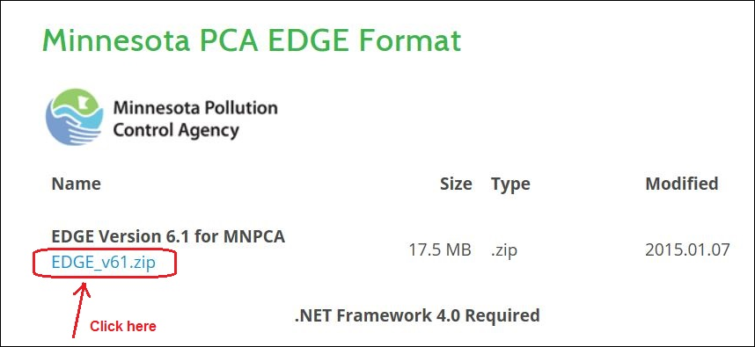

  - Open EDGE
    - Start EDGE by navigating to the unzipped EDGE folder on your computer and double-clicking on Start_EDGE.exe (shown below).

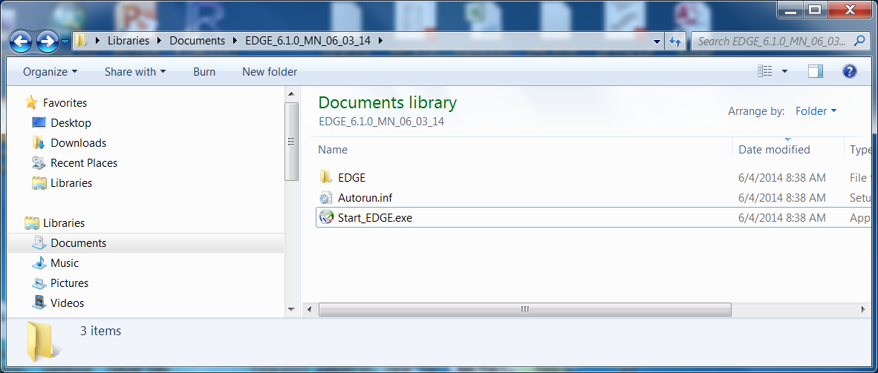

    - When the program opens for the first time, it prompts you to manually open a format (shown below).

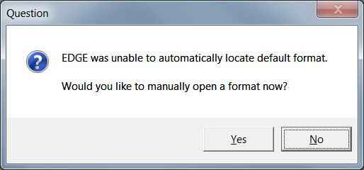

    - Click on the “Yes” button.
    - Double click on the “MN_06_03_14” folder.

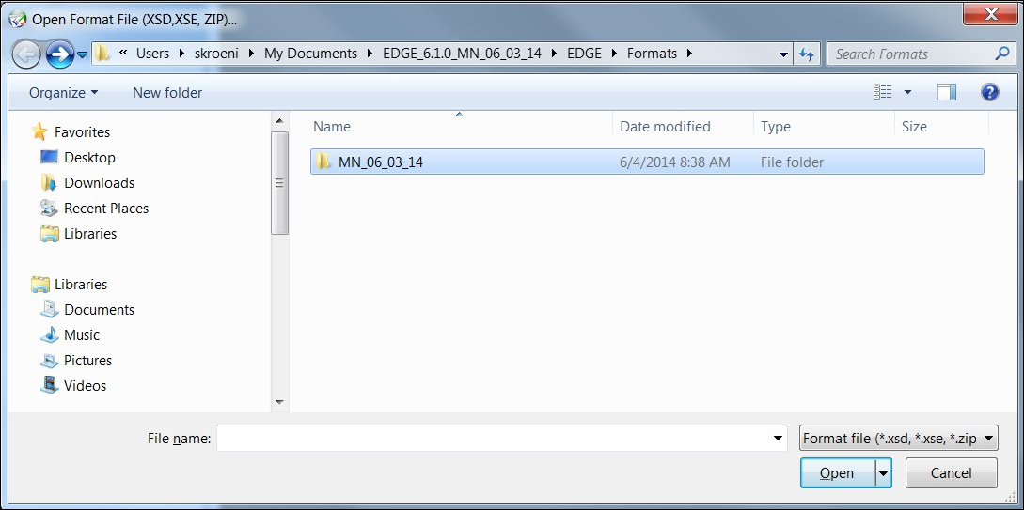

    - Double click on the “EDGE_MN.xse” file to load the Minnesota format.

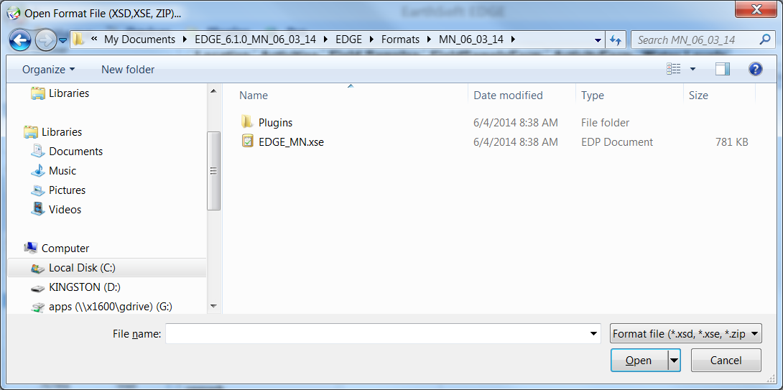

  - Register the EDGE_MN Format
    - EDGE prompts you for registration keys when opened for the first time.

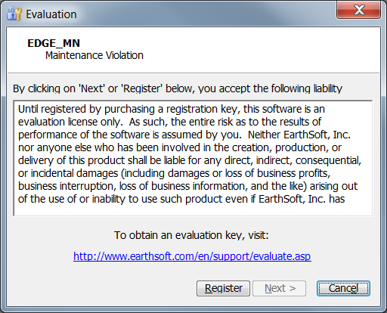

    - Click the “Register” button.
    - The program will prompt you to register for new keys (shown below).

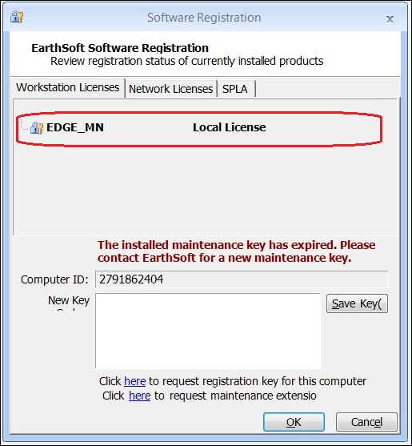

    - Click on the “Click here request registration key for this computer” link. (Maintenance keys are required annually, which lets EarthSoft know the MPCA’s subscription is up-to-date.) A request form will pop up.

    - Note: Do NOT change the value in the Computer ID box. This is automatically generated, and your license keys will work only with this ID. The Computer ID value in the figure below is an example only.

    - Fill out the required fields (in red) on the Format Registration form (shown below). You will use this form to request registration keys from EarthSoft. Use the authorization code: Field42MinnEq

    - Click the “Submit” button in the lower left-hand corner of the screen.

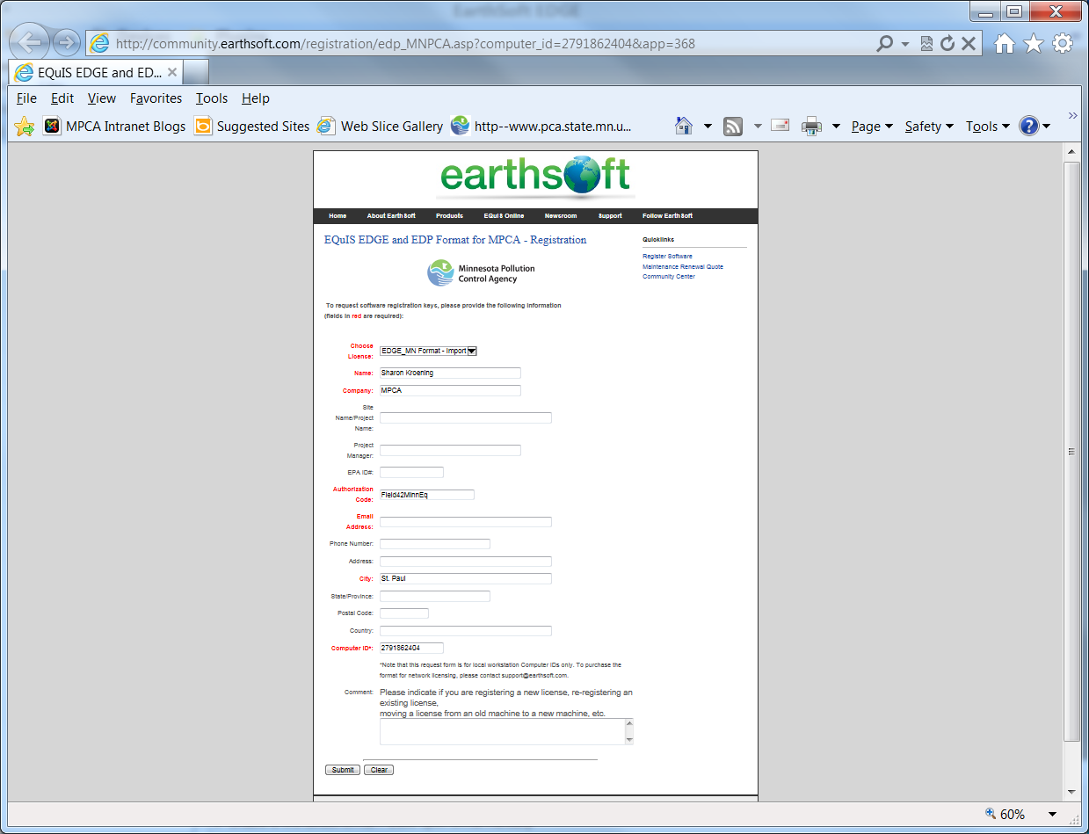

    - You will receive a pop-up message and an email that EarthSoft is processing the registration or maintenance key request (shown below).

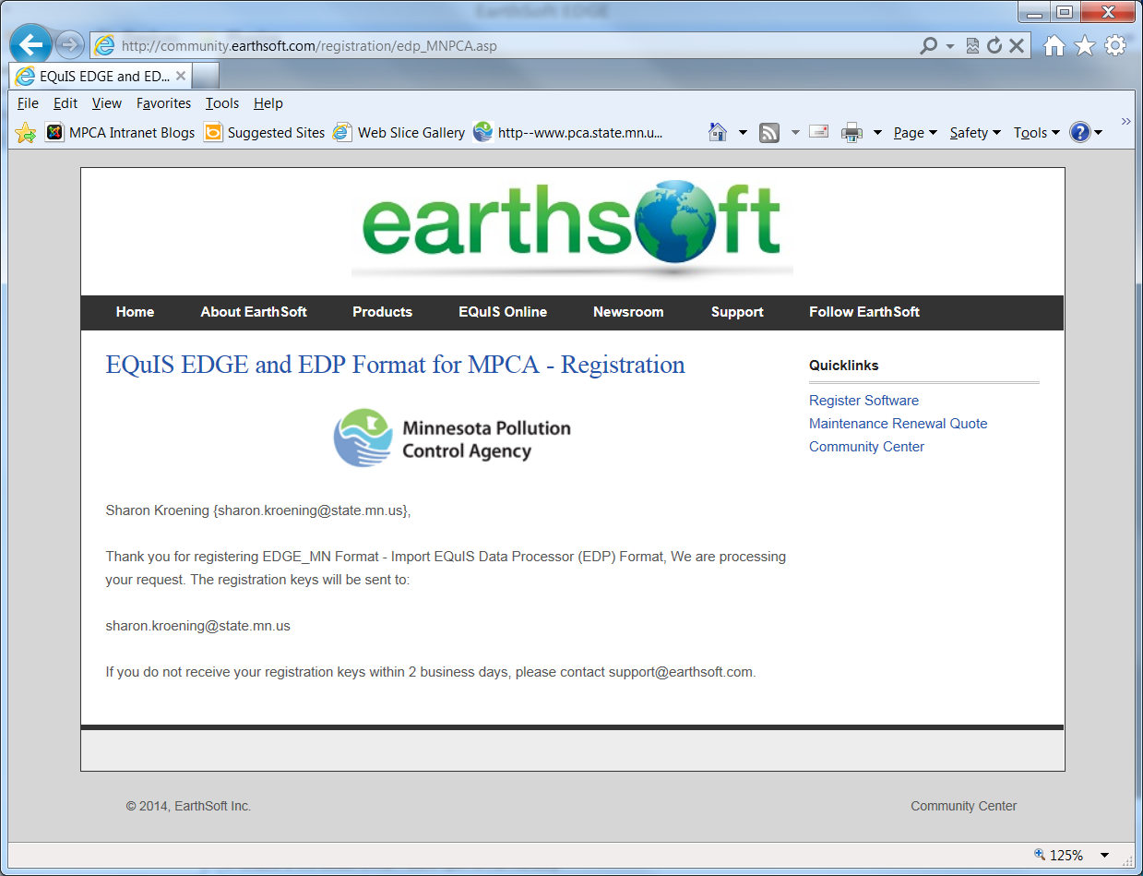

    - You will receive another email from EarthSoft with the registration keys. The keys are circled in red, in the graphic below. NOTE: unique registration keys are required for each format registration. If the format is registered to a USB drive, you can run the Minnesota format from that USB drive using any computer. You cannot copy the files from the USB drive to a computer and run the Minnesota format directly from that computer.

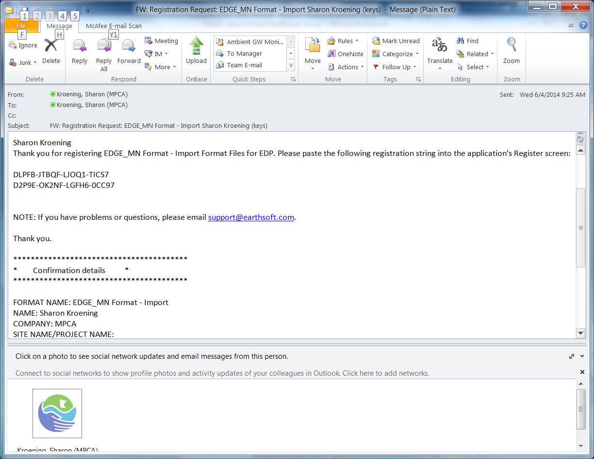

    - Copy and paste the new registration keys into the EarthSoft Software Registration window. (It’s best to copy and paste vs. entering in the numbers manually, as the return key doesn’t always function in the New Key window.)
    - (If you closed the window, the Software Registration window can be opened by clicking on the EDGE logo in the upper left-hand corner of the computer screen and then clicking on the “Register” button.)

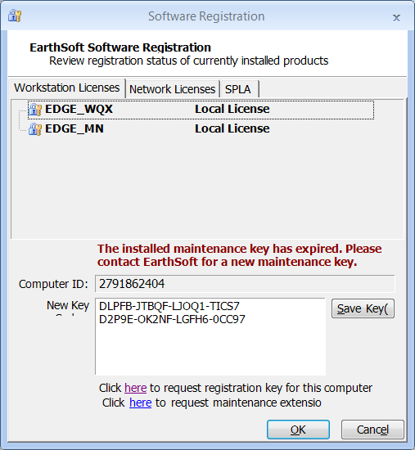

    - Click on the “Save Key” button.
    - Click on the “OK” button.

    - From now on, EDGE will open automatically with the EDGE_MN format, and the steps in this section generally will not need to be repeated.

  - Replace the standard MPCA configuration files with the Remediation Division configuration files.
The Remediation Division has made some customizations to the standard MPCA EDGE configuration, which are applied by replacing a folder and a file in the EDGE folder. You can request them from the Remediation EQuIS team at RemEQuIS.MPCA@state.mn.us.
    - Close EDGE if you have it open.
    - Navigate back to and open the EDGE_6.1 folder and then the EDGE subfolder. Locate the Formats subfolder and rename it to Formats-Old. Now change the Settings.xml file to Settings.xml.old. You can delete both of these once you have loaded the Remediation configuration files and know that EDGE is working properly.
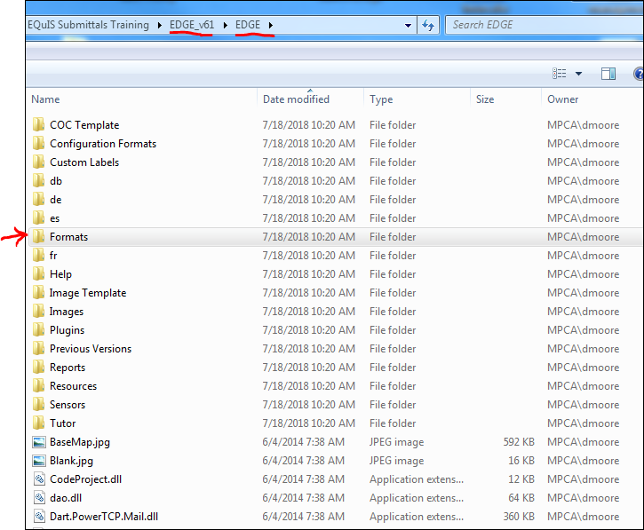

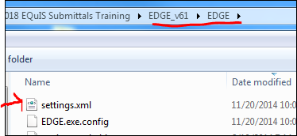

    - If you requested the Formats folder and the settings.xml from the MPCA, you will likely receive a ShareBase link to a folder that looks like the image below. Copy the Formats folder and the settings.xml file and paste them into (EDGE_6.1\EDGE).

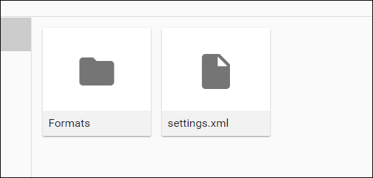

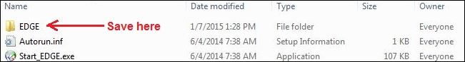

    - EDGE now has the most up-to-date configuration.

Starting EDGE

Navigate to the EDGE_v61 folder

  - Open EDGE by double clicking on the Start_EDGE application file, located in the EDGE_v61 folder
  - If you are starting from scratch, then continue to Step 3.
  - If you have an existing EDGE EDD you want to load, click on the “Home” tab of the toolbar ribbon
  - Click on the “Open EDD” button

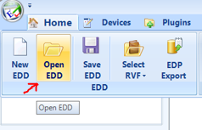
  - Navigate to the EDGE EDD
  - Double-click on the file, or highlight the file and click on the “Open” button

Creating a Project Task

Project tasks identify which MPCA program requested or paid for the sampling. A Project Task needs to be created (or exist already in the EDD) before locations, sample information and field measurements can be entered. To add a new task:

  - Navigate to the “Task Chooser” in the upper left hand part of the screen (shown below).

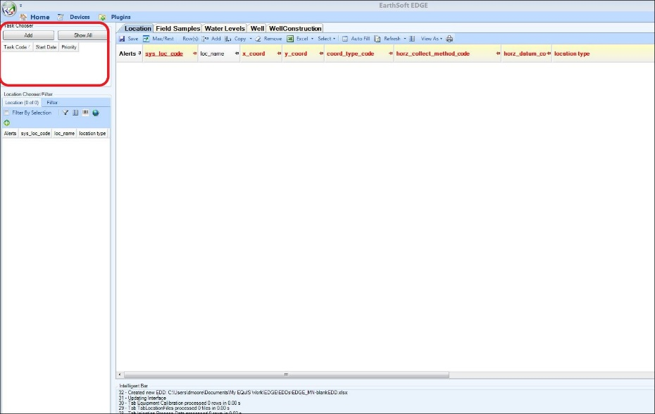

  - Click on the “Add” button in the Task Chooser (shown above).

  - Enter the appropriate value in the “Task Code” line and then click the Add Task button.

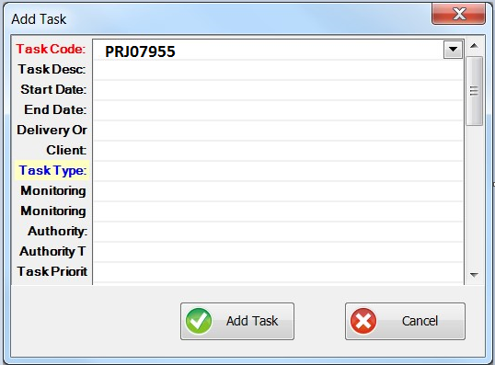

Task Codes for Remediation programs.

PROGRAM | TASK CODE
Closed Landfill | PRJ07786
RCRA Remediation | PRJ08104
Site Assessment | PRJ08103
Brownfields – VIC and PBP | PRJ08105
Petroleum Remediation | PRJ07884
Superfund | PRJ07955
East Metro PFAS - Project 1007 | PRJ08141
PFAS sampling for Lakeland | PRJ08165
3M Cottage Grove | PRJ07238
Integrated Remediation | PRJ08500
Emergency Management | PRJ08196

Creating Location Records

Insert a table with Location Types

Follow these instructions to create new location records. Location records need be established before creating sample records.
Note: You can reuse an EDD that had been submitted in the past, to preserve location records (recommended). However, you must delete all records from the other tabs, including COCs.

  - Highlight the task you created, click on the Location tab and then click on Add (record).

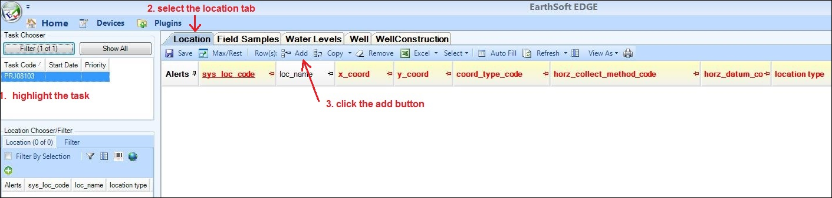

  - Populate all required (red) fields; loc_name is the common name of a location, such as MW-1 or SB-1.
  - For sys_loc_codes, use:
- the LUIs you created using the LUI Generator (See Appendix A: Obtaining Location Unique Identifiers)
- the LUIs sent to you by the MPCA, or
- the MN Unique Well numbers for permanent wells, 15 feet or greater.

Table of most common Location Types
Location Type | LUI Source | LUI Generator Type
Borehole | Use LUI Generator | Borehole
Sump | Use LUI Generator | Borehole
Test Pit | Use LUI Generator | Borehole
Building-Exterior | Use LUI Generator | Building-Exterior
Building-Interior | Use LUI Generator | Building-Interior
Gas-Monitoring Probe | Use LUI Generator | Gas-Monitoring Probe
Gas-Subslab | Use LUI Generator | Gas-Subslab
Lake | Request LUI from MPCA | N/A
Pond | Request LUI from MPCA | N/A
PubWtrSup-POU | Request LUI from MPCA | N/A
River/Stream | Request LUI from MPCA | N/A
Sanitary Sewer | Request LUI from MPCA | N/A
Well-Domestic | Use MN Unique Well ID | N/A
Well-Monitoring | Use MN Unique Well ID | N/A
Well-PubWtrSup | Use MN Unique Well ID | N/A

  - For coord_type_code, use UTM-Z15N.
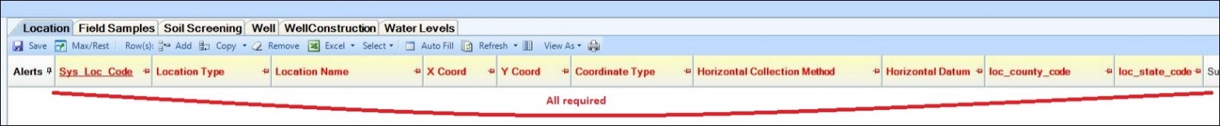
  - Leaving mandatory fields unpopulated results in “Alerts”
  - Populate remaining optional fields if information is readily available.
  - Where a drop-down exists, use it to select a value – do not type in a value that doesn’t exist in the drop-down.

Creating Field Samples

Field samples are associated with a sample location.

For typical well sampling, in which a groundwater sample is collected, two Field Records will likely need to be created: one with sample_type_code = FMO for field parameters and one with sample_type_code = sample for samples submitted to a laboratory. If multiple, discreet groundwater samples are collected from the same well or borehole, then multiple Field Records need to be created with sample_type_code = sample.

Note: Because the “FMO” and “sample” contain similar information, you may want to consider copying the first record to make a new record, and then changing the sample_type_code on the second record, as discussed in Section 6.

  - Select a sample location from the Location Chooser/Filter window by clicking on the row of the location you intend to sample.

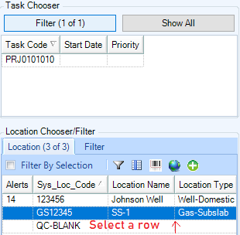

  - Click on the “Field Samples” tab in the toolbar ribbon.
  - Click on the “Add” button to add a new field sample for the location selected.
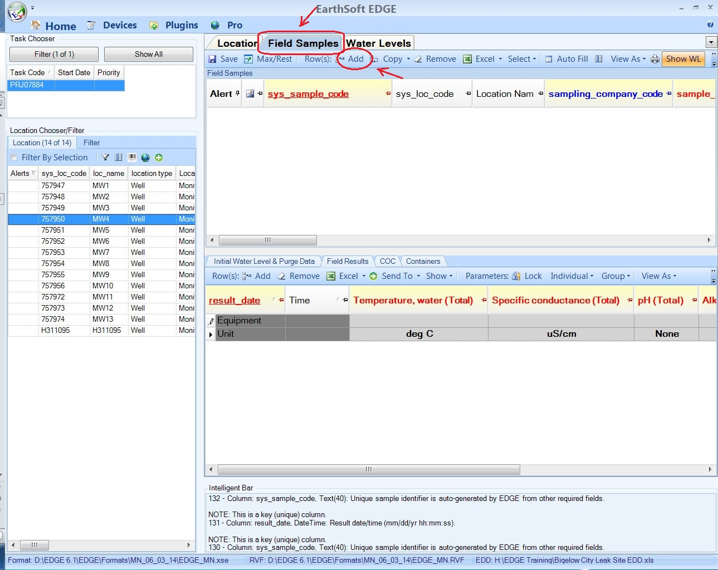

  - Enter the required and known optional information.
Enter values for fields shown in the RED font (EDGE will autopopulate some of the fields – do not edit the sys_loc_code).

    - Sys_sample_code (Populated by EDGE)
The sys_sample_code is a unique identifier generated by EDGE. This code will populate automatically after the values for the sample collection date and time and the sample_type_code have been entered. Do not change the sys_sample_code or add characters to it.
Note: the current EDGE format contains a bug that inserts extra language into and highlights yellow some sys_sample_codes. Please remove the words between the capital “S” and the last letter, usually a capital “A” or a capital “L.” The image below shows a sys_sample_code before and after removing the words.
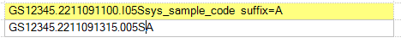

    - Sys_loc_code (Populated by EDGE)
This field will automatically be populated by EDGE.

    - Location Name (Required)
This field will populate automatically when Location Name is populated on the Location record. Location Name is the common name for the sample location - MW-1, SB-3, etc.

    - Project Id (Required).
The project id is the same as the Task Code and identifies the MPCA Program collecting the data
      - Enter the appropriate “ProjectID” or “Task Code” (listed below) in the “projectid” box.

PROGRAM | TASK CODE
Closed Landfill | PRJ07786
RCRA Remediation | PRJ08104
Site Assessment | PRJ08103
Brownfields – VIC and PBP | PRJ08105
Petroleum Remediation | PRJ07884
Superfund | PRJ07955
East Metro PFAS - Project 1007 | PRJ08141
PFAS sampling for Lakeland | PRJ08165
3M Cottage Grove | PRJ07238
Integrated Remediation | PRJ08500
Emergency Management | PRJ08196

    - Sampler (Required)
This field stores the name of the field staff who collected the data.
      - Enter the name of the lead field staff

    - Sampling_company_code (Required)
The sampling_company_code is the company employing the field staff who collected the data.
      - Click the drop-down and select your company.
      - Contact remequis.mpca@state.mn.us if a code for your company or organization is not listed.

    - Set the Sample Date and Time (Required).
Sample date and time should populate automatically. You can add or change the values as necessary.
      - Click on the drop-down arrow in the “sample_date” box
      - Select the date on the calendar using the date picker. EDGE will automatically set the “sample_time” to the current time, which can be changed.

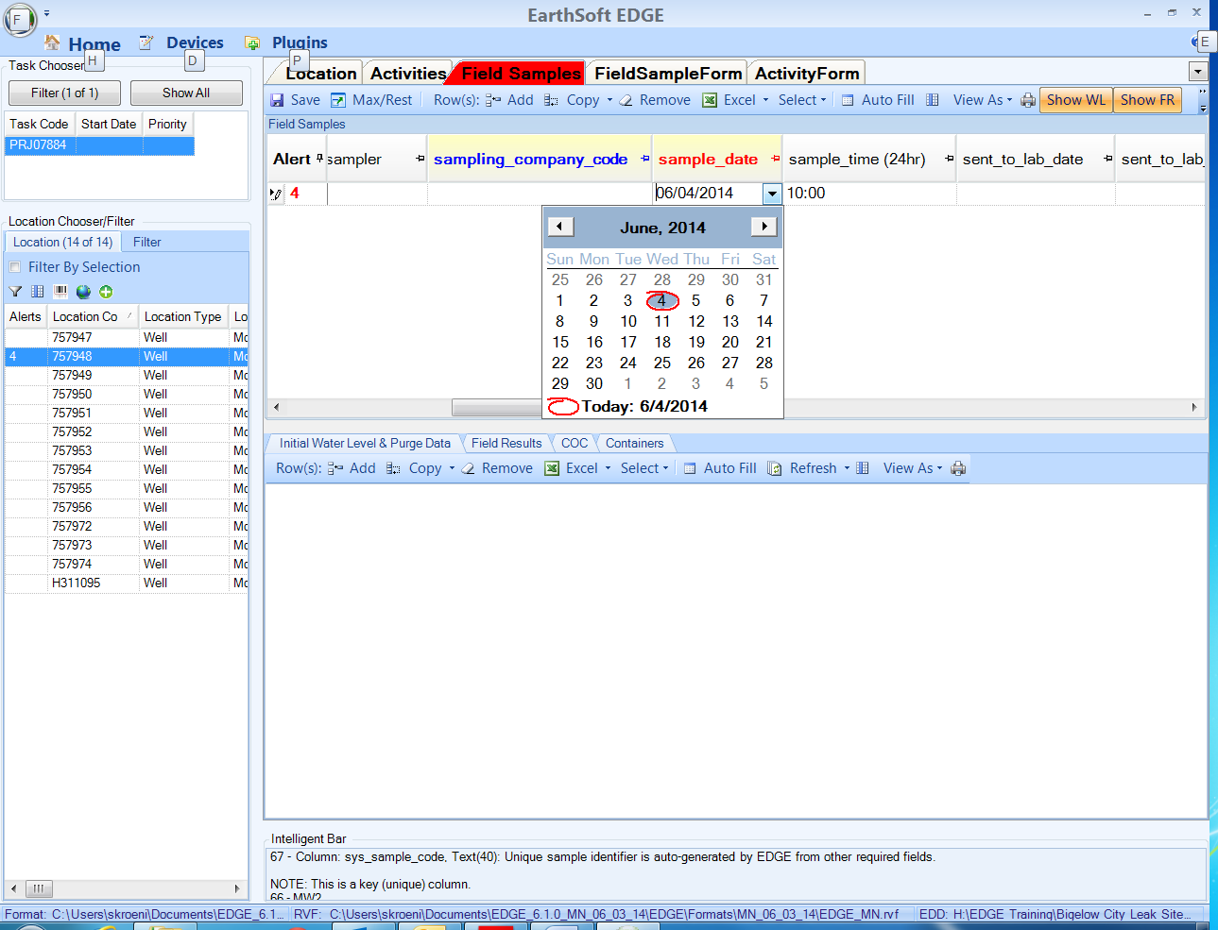

    - Set the Sample Type Code (Required)
“SAMPLE_TYPE_CODE” distinguishes between different types of samples, such as field measurements, routine environmental samples, and quality control samples that are collected from the same location.
      - Click on the drop-down arrow and select the sample type code.

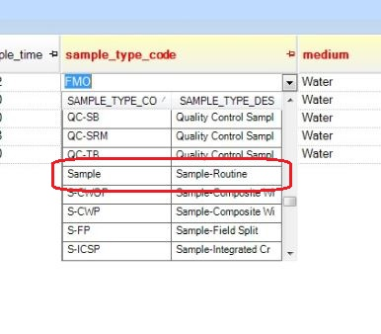
The codes listed below are common sample types.

SAMPLE_TYPE_CODE | SAMPLE_TYPE_DESCRIPTION
Sample | Routine Environmental Sample
FMO | Field Measurement/Observation
QC-FR | Replicate Sample
QC-FB | Field Blank Sample
QC-EB | Equipment Blank
QC-TB | Trip Blank
Treated-Mid | Mid treatment samples
Treated-Post | Post treatment samples
Treatment-Pre | Use for water that is blended, prior to treatment
S-IDW | Investigation-derived waste  If the waste is from a single location, use that location’s sys_loc_code. If the waste is non-location specific, you can either leave the sys_loc_code blank or use QC-BLANK.

Note - Do not select these three sample types:
QC-LD Quality Control Lab Duplicate
QC-LMS Quality Control Lab Matrix Spike
QC-LMSD Quality Control Lab Matrix Spike Duplicate
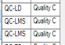

These are lab QC only. Usually, the lab will pick a sample to run these analyses. Sometimes, however, you or the MPCA will request these analyses be run on specific samples. If that is the case, then indicate that on the COC. Do not create Field Samples records for these lab QC analyses.

    - Set the Medium Code (Required)
The Medium Code describes whether a water, air, sediment, or tissue sample was collected.

      - Click on the drop-down arrow and select the appropriate medium code.

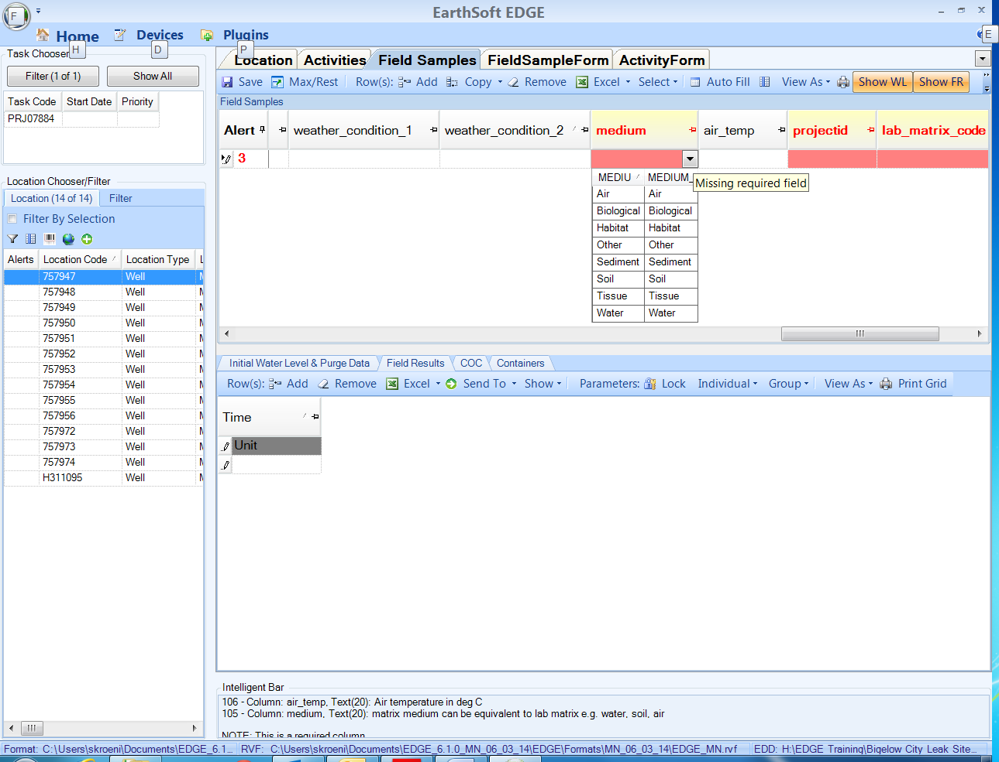

    - Set the Sample Matrix Code. (Required)
The “Sample Matrix Code” distinguishes between different sample matrices, such as surface water, groundwater, leachate, or soil gas.
      - Click on the drop-down arrow and select the appropriate “MATRIX_CODE”. For routine groundwater samples this will be “Wtr-Ground” and for municipal and residential wells use Wtr-Drink. For soil, use either “Soil-Sub” or “Soil-Surf” and for soil gas use “Gas-Soil”. For field blank, equipment blank and trip blank samples, the MATRIX_CODE is “QC-BLANK”.

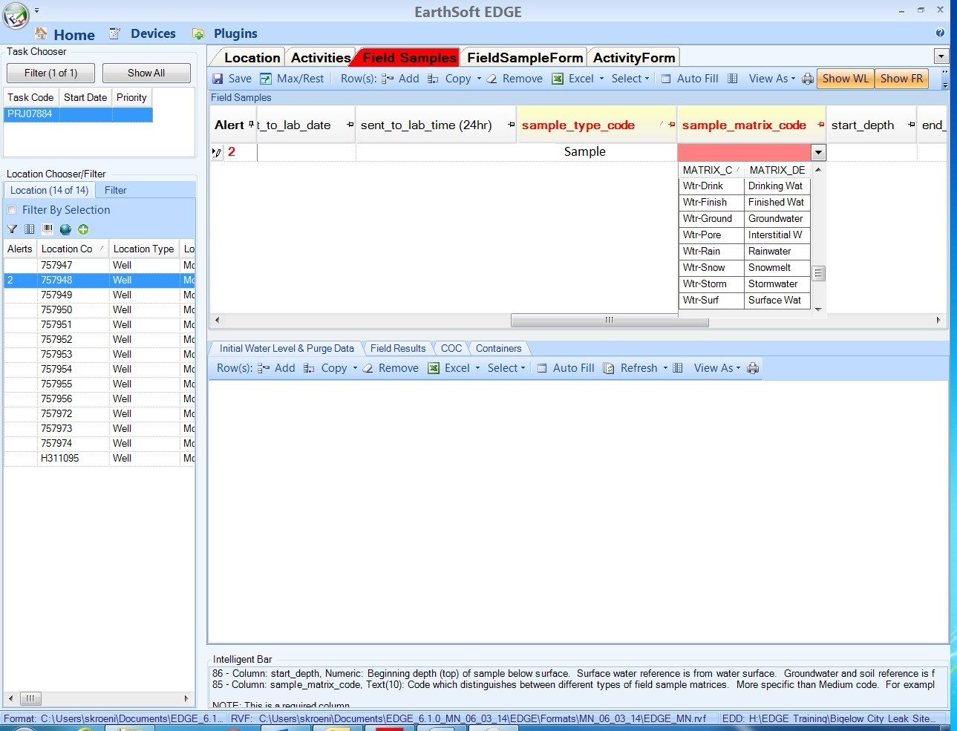

    - Set the Lab Matrix Code (Required).
The lab matrix code populates information on the COC to help laboratories determine which analytical methods should be run on the submitted samples.
      - Click on the drop-down arrow and select the appropriate “MATRIX_CODE”. For monitoring well samples, select “NW” for non-potable water, and for drinking water wells select “DW” for drinking water.

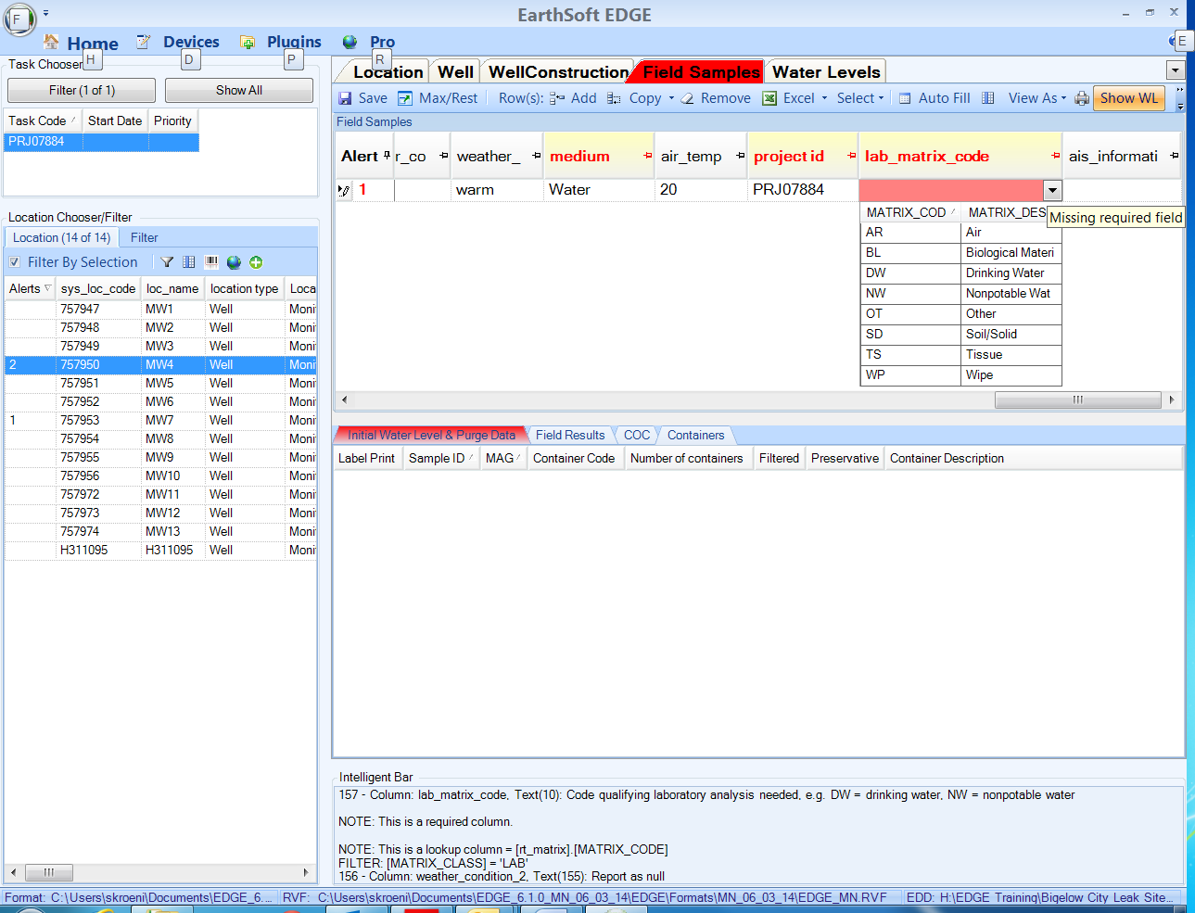

    - Set the Sampling Method (Required).
      - Click on the drop-down arrow and select the appropriate method code. For routine groundwater samples, this will be “WELL-BAIL”, “WELL-NONSUBMERS”, or “WELL-SUBMERS”. Residential wells are typically “WELL-NONSUBMERS” and soil samples will commonly be SW-Soil. For Trip, Equipment and Field Blanks, use QC_BLANK.

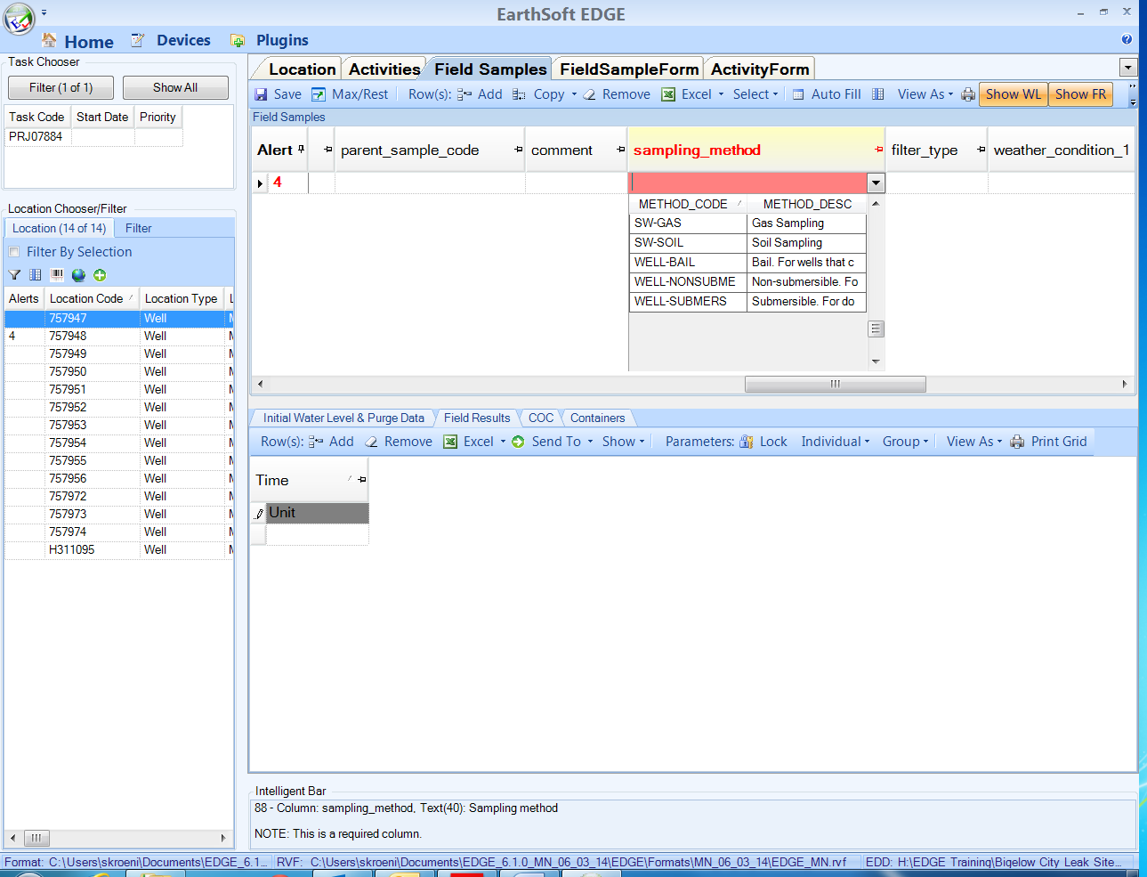

Here are the most common sample methods:
sampling_method | description
QC-BLANK | Quality control blank.
SHALLSOIL | Shallow soil grab sample
SOILBORI | Boring, soil sample extraction
SW-GAS | Gas Sampling
SW-SOIL | Soil Sampling
WELL-BAIL | Bailer
WELL-NONSUBMERS | Non-submersible pump.
WELL-SUBMERS | Submersible pump.

    - Start depth (Required for soil)
Beginning depth (top) of sample below the surface: for surface water, the reference is from water surface; for groundwater and soil the reference is from ground surface; for sub-slab the reference is from the top of slab; for indoor and outdoor air, the reference is from the ground surface, but if a cannister is placed at breathing level, the starting depth will be negative.
For groundwater samples, enter the depth of the pump below ground surface in feet or enter zero if unknown.

This is the only value entered if there is not a depth range.

    - End depth (Optional for Indicating Depth Range)
End depth references are the same as start depth references.

    - Depth_unit (Required)
This field indicates the measurement units for the start and end depths and defaults to units of feet.

    - Filter_type (*)
This is a text field that is used for entering the pore size of the filter used.
(Delete values that are auto-populated in this field.)
*This field is required only if a filter was used.

    - Parent_sample_code (Required for duplicate samples)
Populate this field if the sample is a duplicate. Click on the drop down and select the sys_sample_code of the parent sample (sample being replicated). Do not replicate samples with a FMO Sample Type.

    - Composite_yn (Required)
This field indicates if the sample is a composite
      - A value of “Y” is entered for composite samples, and a value of “N” is entered for all other samples.

    - Composite_desc (Optional*)
This is a text field that further describes the type of composite sample that was collected. *This field is required if a value of “Y” is entered for “composite_yn”.

    - Comment (Optional)
This is a text field that contains comments from the field about the sample, such as whether they were filtered in the field, etc.

Copying and Editing Field Samples Records

As discussed in the beginning of Section 5, there can be multiple Field Samples records for one sample location, depending on if QA/QC samples are collected or if soil samples are collected from multiple depths. For groundwater and drinking water samples where field parameters are recorded (most often) there will be a minimum of two Field Sample Records: one for the analytical samples (not including QA/QC) and one for field parameters.

It’s easiest to create one Field Sample record and then copy it and change the appropriate values, in the duplicate record, to create a unique record.

  - Highlight the row you want to copy and click on the Copy button. Select “Copy.” A colorful duplicate of the record will be created at the bottom of the data grid. The blue and yellow highlighting indicate this record is an exact duplicate, which is not allowed in this table.

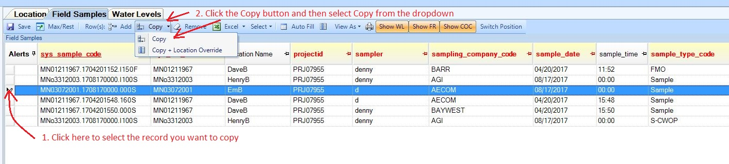

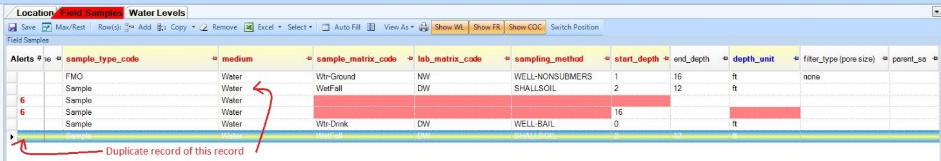

  - Change the necessary fields. If you are copying a record with sample_type_code “Sample,” then you may want to change the sample_type_code to FMO, which is for field parameters. If you are recording a “Sample” and “FMO” sample types, give them unique times. Change the value of other fields as necessary.

Entering the Initial Water Level and Purge Information (Required for water samples)

The “Initial Water Level & Purge Data” tab is used to record water level measurements that were collected before doing field measurements and water samples are collected. Section #10 provides directions for recording water level measurements that are collected more than a day before field measurements and water samples are collected.

  - Highlight the field sample record with an FMO Sample Type associated with the water level measurement.
  - Click on the “Initial Water Level & Purge Data” tab located in the middle of the computer screen.
  - Click on the “Add” button.

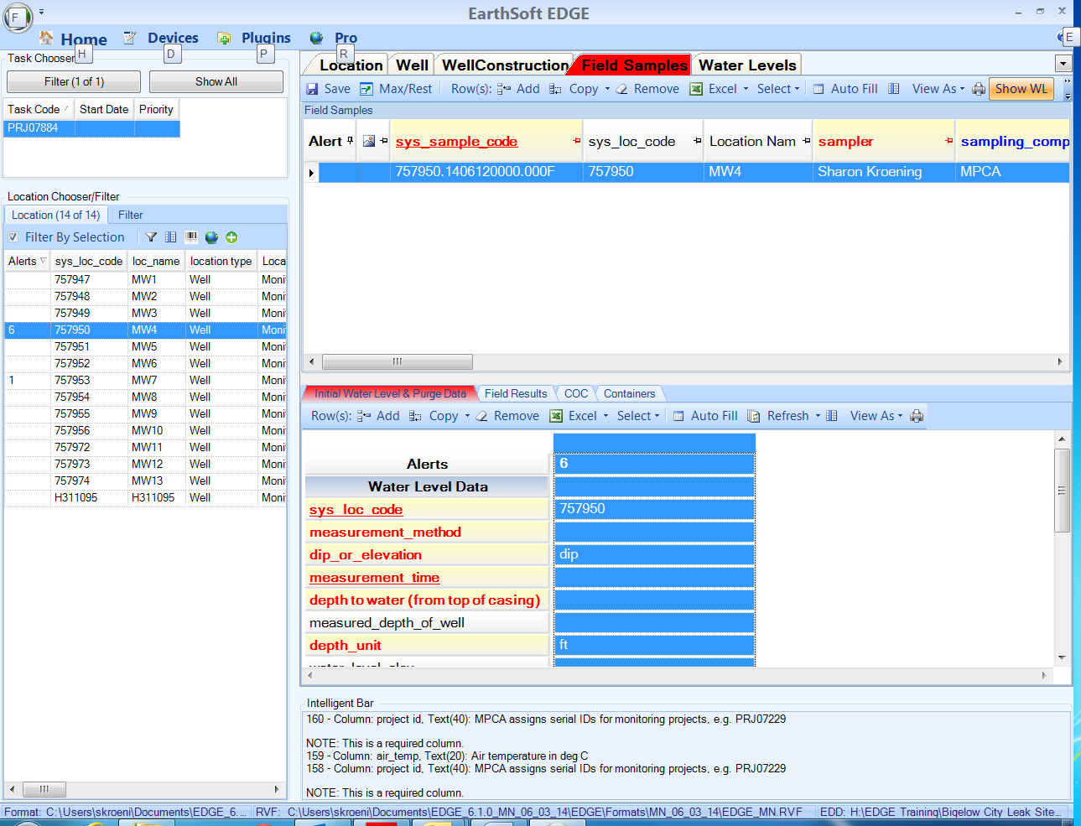

  - Enter the required (RED) field information.
    - Sys_loc_code (Autopopulated)
      - This field populates automatically when “Initial Water Level & Purge Data” are added.

    - Measurement Method (Required)
This field denotes whether the measurement was made with an electric or steel tape.
      - Click on the drop-down arrow and select the appropriate method used to measure the water level in the well.

    - Dip_or_elevation (Required)
This field denotes whether the water level is above or below the datum. A value of “dip” is used for all groundwater level measurements. This field populates automatically with a value of “dip” when data are added.

    - Measurement Time (Required).
      - Enter the measurement time

    - Sample_date (autopopulated)
This is the date the water level measurement was taken. This field populates automatically when a new “Initial Water Level & Purge” record is created.

    - Depth_to_water (from top of casing) (Required)
      - Enter in the water level depth (in feet) from the top of the well casing.

    - Measured_depth_of_well (Optional)
This field contains the depth from the ground surface to the bottom of the well. Populate this field if the depth is known.
      - Enter the well depth in feet.

    - Depth_unit (Required)
This field denotes the units the of the measured water level depth. This field defaults to feet.

    - Well_diameter (Optional)
This field contains the diameter of the well. This field is necessary to calculate volume.
      - Enter the well diameter in inches

    - Diameter_unit (Required if Well Diameter is populated)
This field contains the well diameter units and is automatically populated with a unit of inches.

    - Well_volume (autopopulated)
This field contains the volume of water in the well casing. This is calculated automatically from the measured depth of the well, water level depth, and the diameter of the well casing.

    - Purge_vol_unit (Optional)
This field contains the units of the calculated and actual purge volume.
      - Select the appropriate unit. Usually, a unit of “gal” is selected.

    - Well_volumes_to_purge (Required)
This field describes the number of well volumes to purge from the well prior to sampling and should be set to a minimum of 3 well volumes.

    - Calculated purge volume (autopopulated)
This field contains the calculated volume of water to be purged from the well. This value is automatically calculated (in gallons) based on the measured well depth, water level depth, well diameter, and well volumes to purge.

    - Purge_method (Required)
This describes the technique used to purge the well.
      - Click on the drop-down and select the appropriate method used to purge the well.

    - Actual purge volume (Optional)
This is the actual measured volume of the water purged from the well.
      - Enter the actual purge volume, in gallons.

    - Remark (Optional)
This field contains any comments associated with the water level measurement and purge volumes.

    - Sys_sample_code (autopopulated)
The sys_sample_code is a unique identifier generated by EDGE.
      - This field populates automatically when a new “Initial Water Level & Purge Data” record has been added.

    - Purge_rate (Optional)
This field contains a numerical value that indicates the purge rate prior to sampling.
      - Enter the purge rate.

    - Purge_rate_unit (Optional)
This field contains the unit associated with the purge_rate.
      - Click on the drop-down arrow and select the appropriate unit.

    - Sampler (Required)
This field contains the name of the field staff who measured the water level in the well.
      - Enter the name of the field staff who performed the water level measurement.

    - Is well dry? (Optional)
This indicates whether the well contains water.
      - Enter ‘Y’ if the well was dry.
      - Enter ‘N’ if the well contained water.

Field Results
In the Field Results tab you will select a “Field Method Analyte Group” to record field parameters or field tests on samples.

  - Click on the Field Samples tab on the upper window of EDGE and highlight a sample record with Sample Type FMO.
  - Click on the Field Results tab in the menu bar near the bottom of the screen.
  - Click on the “Group” drop-down button, which is circled in red below.

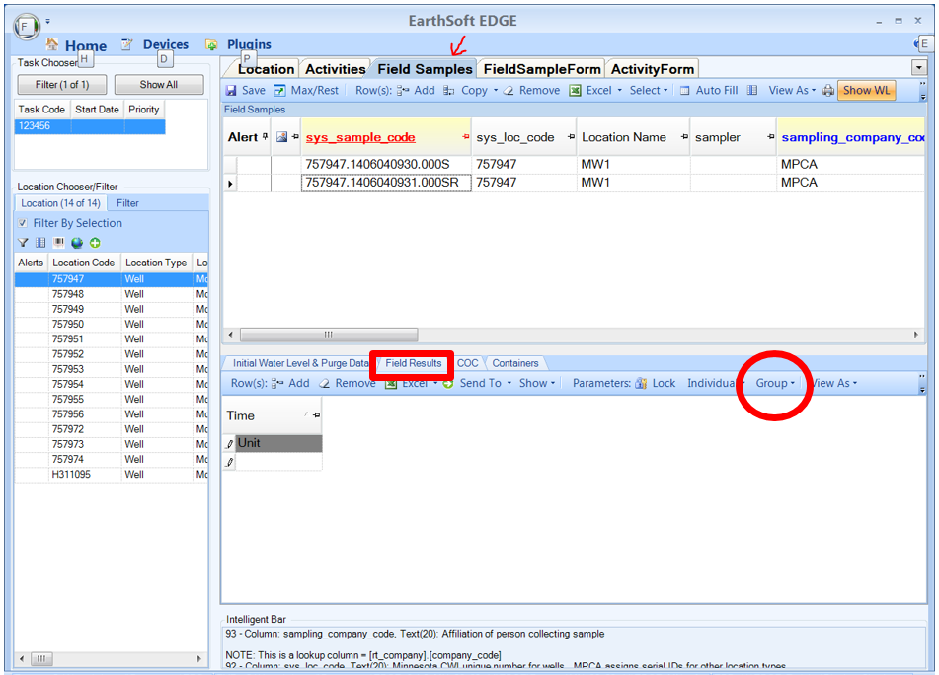

  - Select the Remediation Well Stabilization group and then choose the “Show All Members” option. You can select any group and choose “Show All Members.” Make sure you confirm with the PCA Project Manager which parameters should be collected for the Site.

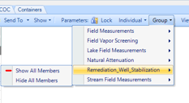

  - When recording field parameters for vapor sampling, select show all members in the Field Vapor Screening group.

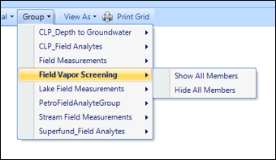

  - The Field Method Analytes should now appear on the computer screen, as shown below.

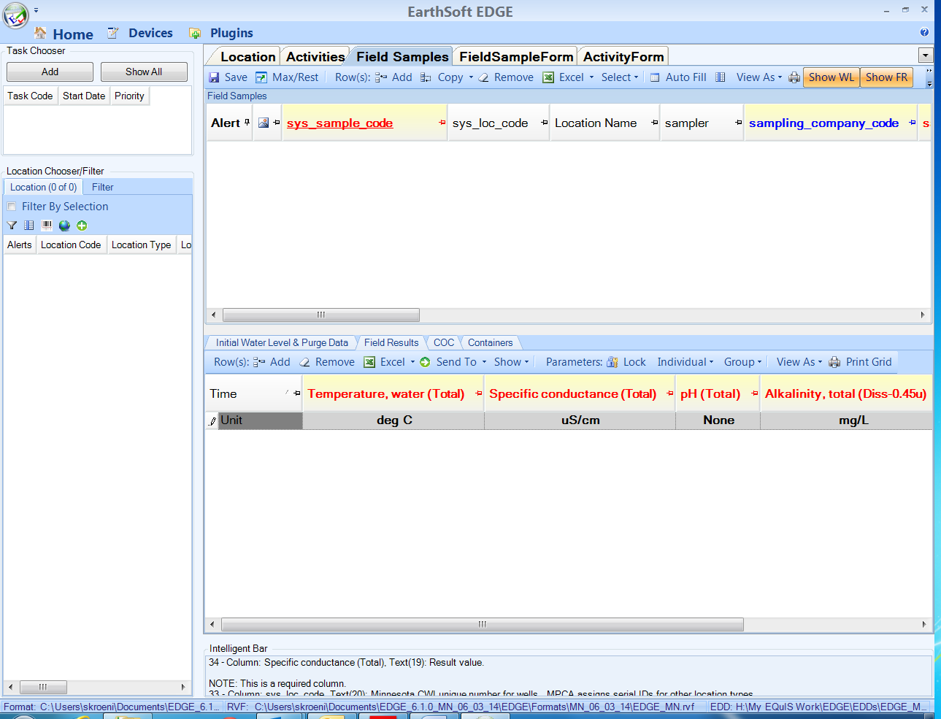

  - Populate fields that are required for the site. Values will be highlighted in orange if they are outside of the typical range.
  - To add measurements for another sample, highlight the Field Samples record in the top data grid, and then click on the “Add” button in the Field Results data grid.

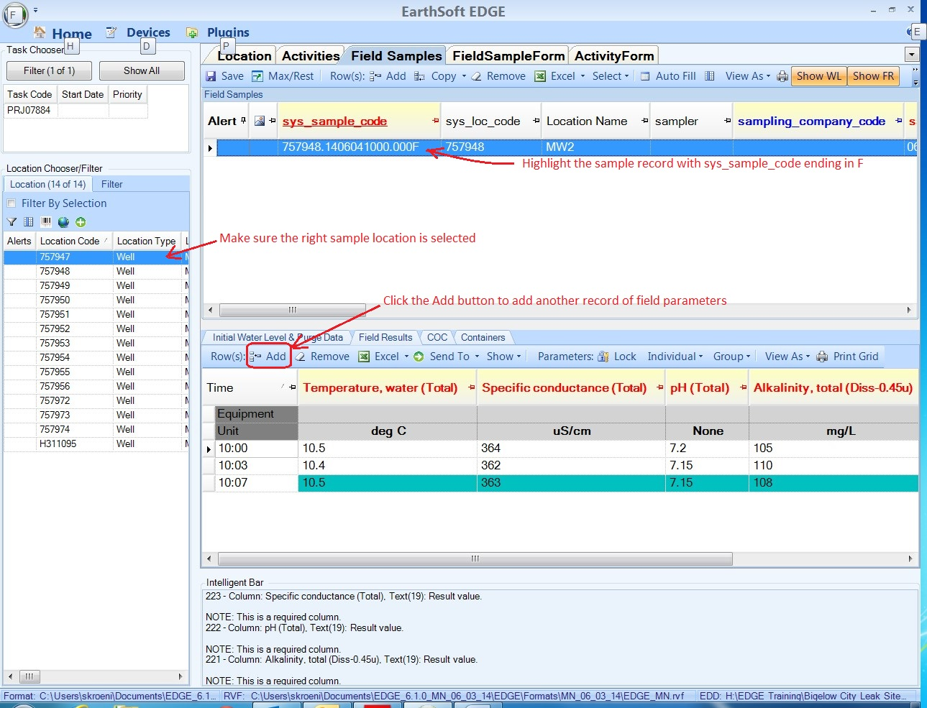

Entering Only Water Level Information

This section describes how to record water level measurements in EDGE, when the measurements are not associated with a sampling event.

  - In the Location Chooser/Filter select a location by clicking anywhere on the row.
  - Click on the “Water Levels” tab in the upper part of the computer screen, and click on the “Add” button to create a new water level record.

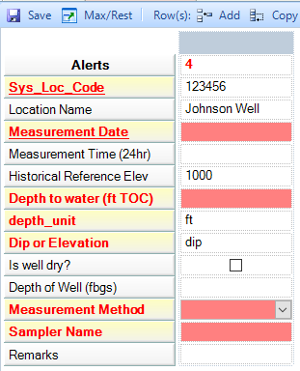

  - Sys_loc_code (autopopulated)
This field will automatically be set when the water level measurement is added.

  - Location Name (autopopulated)
The location name is the common name for the site. For wells, this often is MW-1, MW-2, etc. This field will automatically be set when the water level measurement is added.

  - Measurement Date (Required).
    - Click on the drop-down arrow, and use the calendar to select the appropriate date.

  - Measurement Time (24 hr) (Required).
    - Enter the time the water level measurement was taken, in 24-hour format, for example 14:30.

  - Historical_reference_elev (autopopulated)
This is the elevation of the measuring point on the well. This field is automatically populated when the top of casing elevation is recorded in the Location tab of the EDD template.

  - Depth to water (ft TOC) (Required)
    - Enter the water level depth (measured from the top of the well casing).

  - Depth unit (Required)
This field defaults to feet.

  - Dip_or_elevation (Required)
This field denotes whether the water level is above or below the datum. A value of “dip” is used for all groundwater level measurements. This field defaults to “dip” when data are added.

  - Is well dry? (Optional)
This indicates whether the well contains water.
    - Check the box if the well was dry.

  - Measured_depth_of_well (Required)
This field contains the depth below the ground surface to the bottom of the well.
    - Enter the well depth in feet.

  - Measurement Method (Required).
    - Click on the drop-down arrow and select the method used to obtain the water level measurement.

  - Sampler Name (Required).
    - Enter the name of the field staff performing the measurement.

  - Remanrks (Optional)
    - Enter remarks if desired.

Entering Soil Screening Information

The “Soil Screening” tab is used to record information about collecting soil samples

  - Click on the location record in the Location Chooser/Filter.
  - Click on the Soil Screening tab.
  - Click Add – the sys_loc_code is auto-populated.
  - Enter the Sample Date, Sample Time, Depth (from)(ft) and Depth To (ft) values.
  - Enter the remaining information if you have it.
  - The PID field is ONLY for headspace analysis PIDs. For PIDs collected from boreholes, sub-slab points and indoor/outdoor air samples, use the Field Vapor Screening field analyte group discussed in Section 8.

Entering Well and Well Construction Information
If one of your location records is a new monitoring well or a temporary well, you must make a record for those wells in the Well tab.
  - Click on the location record in the Location Chooser/Filter data grid.
  - Click on the Well tab and click Add.
  - The Sys_loc_code field auto-populates, and the Status defaults to Active.
  - Select the Well Use.
  - Populate all optional fields if information is available.
  - If you are entering a well that has been sealed, then change the status to Sealed.
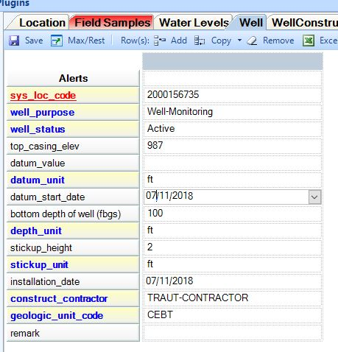

  - Click on the Well Construction tab.
  - Click on the Add rows button
  - Sys_loc_code auto-populates
  - Create a record for each major well segment: stick up, riser pipe and screen.
  - Segment type, material type code and start depth are required.
  - Populate all optional fields if information is available

Only use the following combinations of Segment Type and Material Type. If the exact combination does not exist, pick the closest match.

Segment Type | Material Type
Backfill | Bentonite Grout
Backfill | Cement
Backfill | Native Material
Backfill | Neat Cement
Backfill | Portland Cement
Filter Pack | 15# Red Flint Sand
Filter Pack | 30# Red Flint Sand
Filter Pack | 30# Sand
Filter Pack | 40# Sand
Filter Pack | Native Material
Filter Pack | Red Flint Sand
Filter Pack | Sand
Joint | Glued
Joint | No Joints
Joint | Threaded
Joint | Unknown
Joint | Welded
Lower Seal | Bentonite
Lower Seal | Bentonite Chips
Lower Seal | Fine Sand
Open Hole | Native Material
Protective Casing | Steel
Riser Pipe | Low Carbon Steel
Riser Pipe | PVC
Riser Pipe | S40 Stainless Steel
Riser Pipe | Schedule 40 PVC
Riser Pipe | Schedule 80 PVC
Riser Pipe | Steel
Screen | Channel Pack
Screen | HDPE
Screen | PVC
Screen | PVC Vee Wire
Screen | Schedule 40 PVC
Screen | Stainless Steel
Screen | Stainless Steel V-Wr
Screen | Steel
Screen | Unknown
Surface Seal | Concrete
Surface Seal | Neat Cement
Surface Seal | Portland Cement

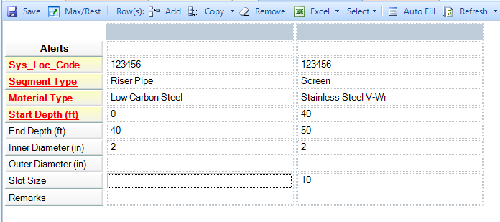

Creating and Populating a Chain of Custody (COC) Form
Follow these steps to create a COC.:
  - Click on the Home tab then select COC Manager.

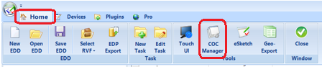

  - If there is an existing COC in the project, it will open; otherwise, click the New button to create a new COC.

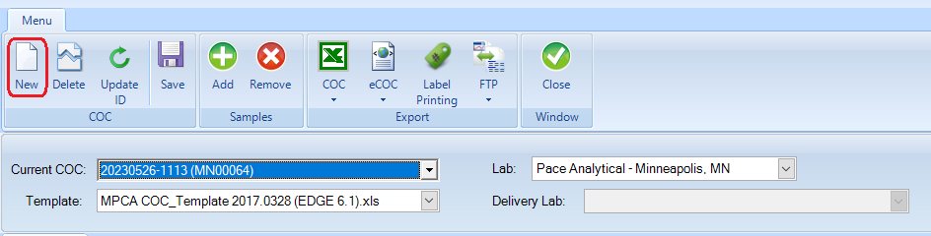

  - If you are creating a new COC, in the Select COC ID screen, you can either accept the system-generated ID or create your own ID. Click OK.
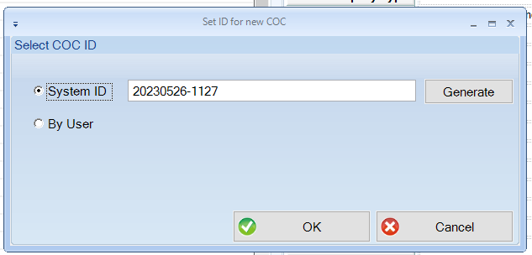

  - Enter the lab that will analyze the samples. Note: you can sort the labs by clicking on the company_name header.

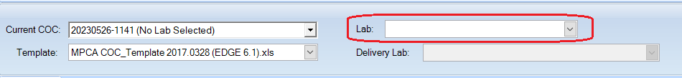

  - Lab information will auto-populate when you select a lab. You cannot edit the lab information.
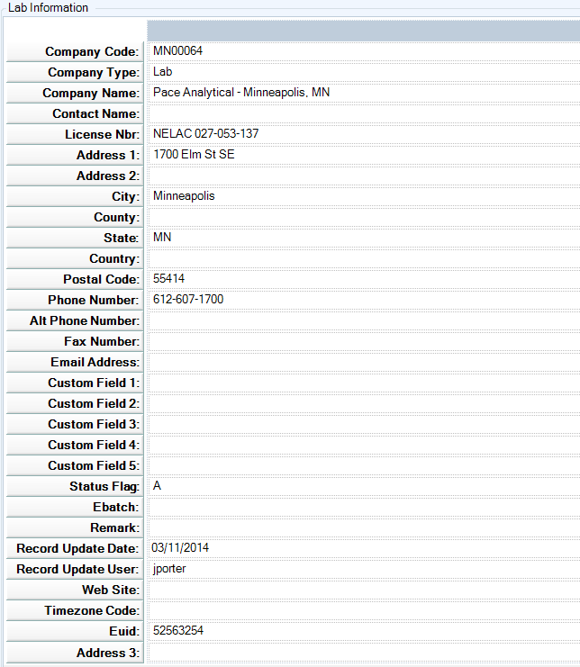

  - Enter the COC information as shown in the image below. Where there is a “No,” you don’t have to enter anything in the field.

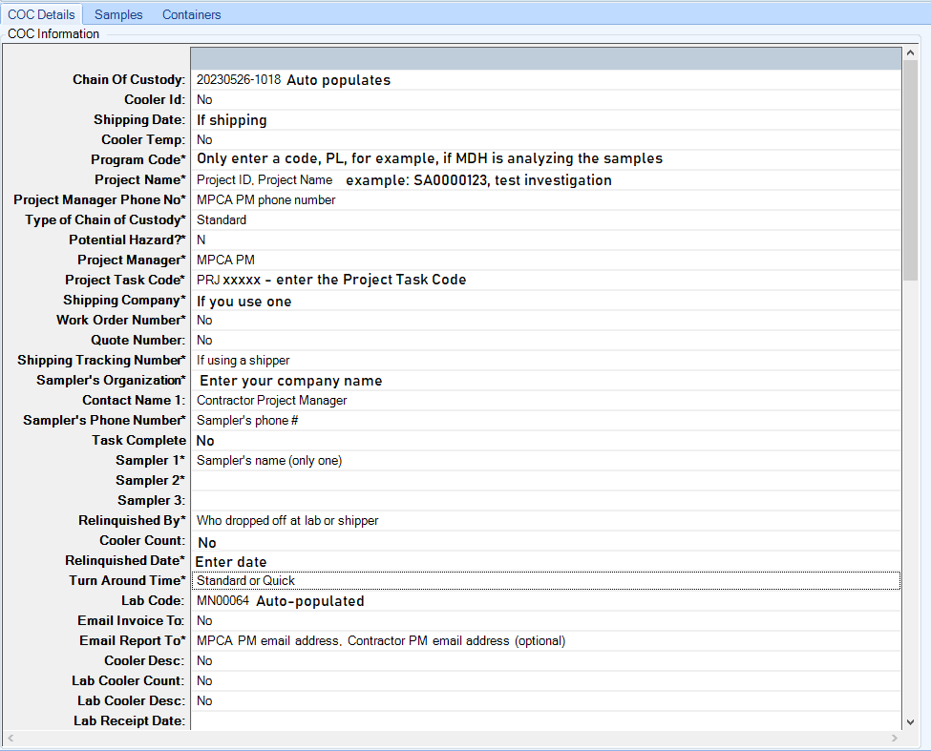

  - Click on the Samples tab, then click on the Add button.
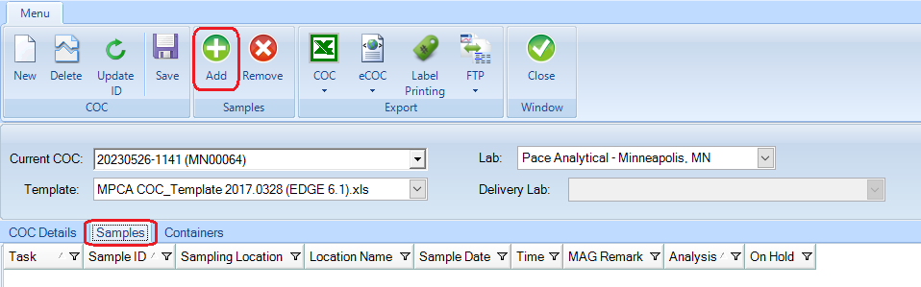

  - Select a sample record, for which Sample_Type is “Sample.” (Never select a record for which Sample_Type is “FMO.”
  - Select the Task Groups tab. You can sort the column by clicking on the column header.
  - Highlight the analysis and click on the Assign Analysis button.
  - Repeat these steps to assign analyses to each sample.
  - Click the Finish button at the bottom of the screen.

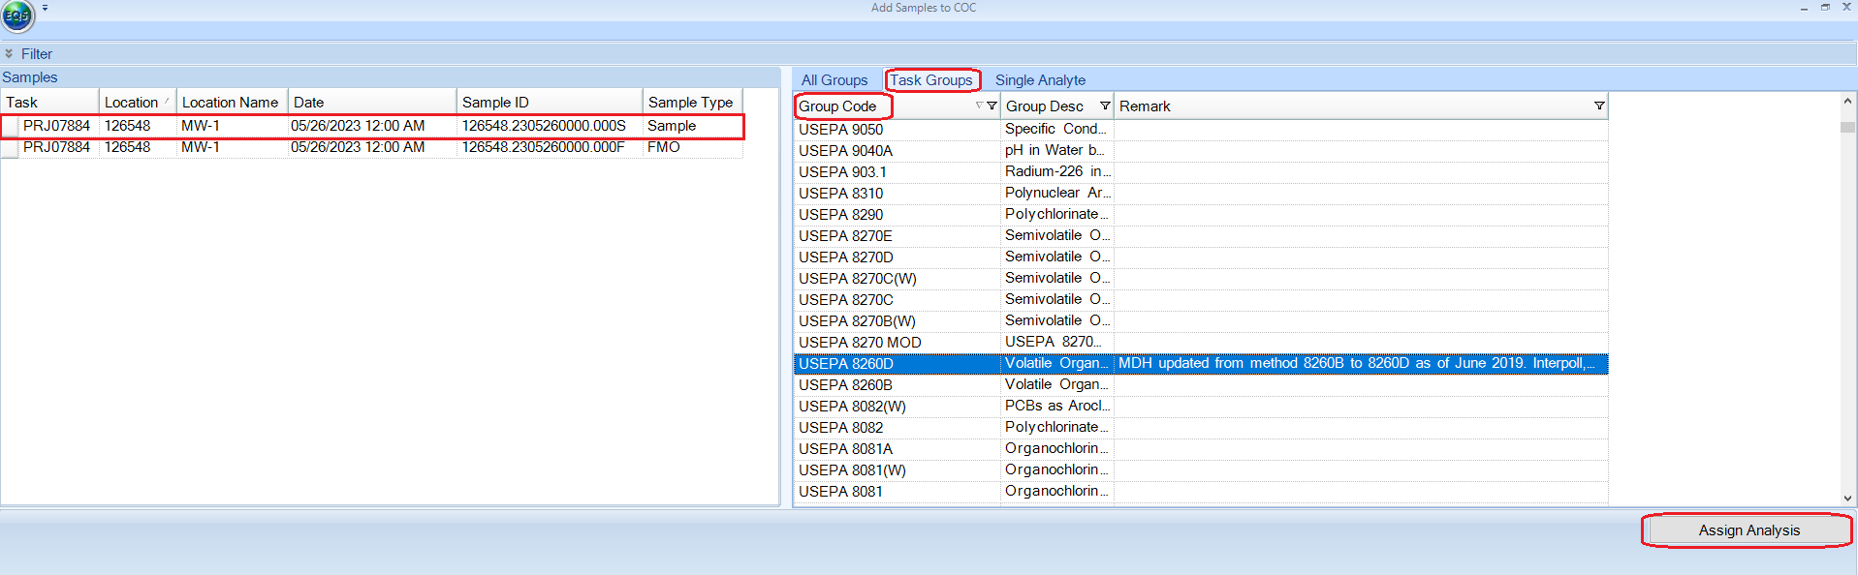

  - Click on the Containers tab.
  - Enter the Container Code, Number of containers, Filtered, Preservative and (optional) Container Description.

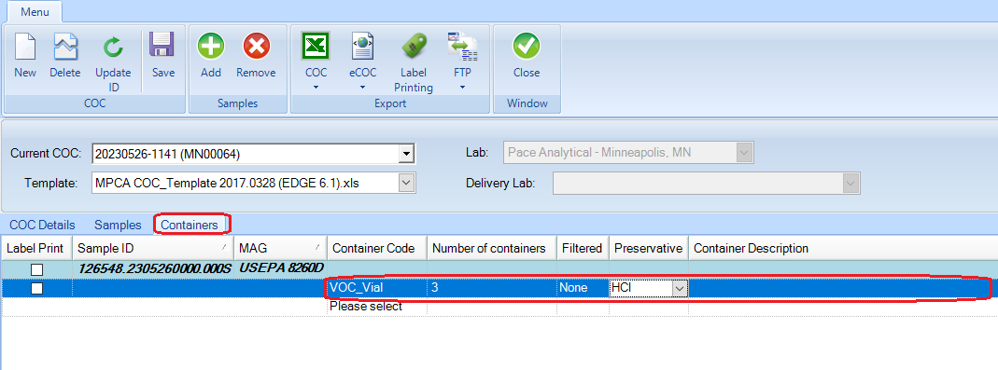

  - Click on the COC dropdown on the top ribbon. Selecting “Export” will open the COC (you will have to click”enable” to see the information), and you will be able to print it. Selecting “Export and Attach” adds the COC to the EDD, but it doesn’t export the COC. Adding the COC to the EDD is preferred but not required.
  - Click the Close button when you are finished.

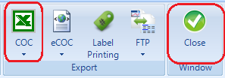

Important: If you start with an EDD that has already been submitted and then delete the sampling information, please delete all COCs that have already been submitted, as well. If you leave a previously-submitted COC in the EDD, then it will cause errors when loading to EQuIS.

Exporting the EDD to Send to the MPCA

The EDP Export function in EDGE exports the completed EDD in a format that is readily imported into MPCA’s EQuIS.

  - Exporting the EDD.
    - Click on the “Home” tab in the upper left hand corner of the computer screen.

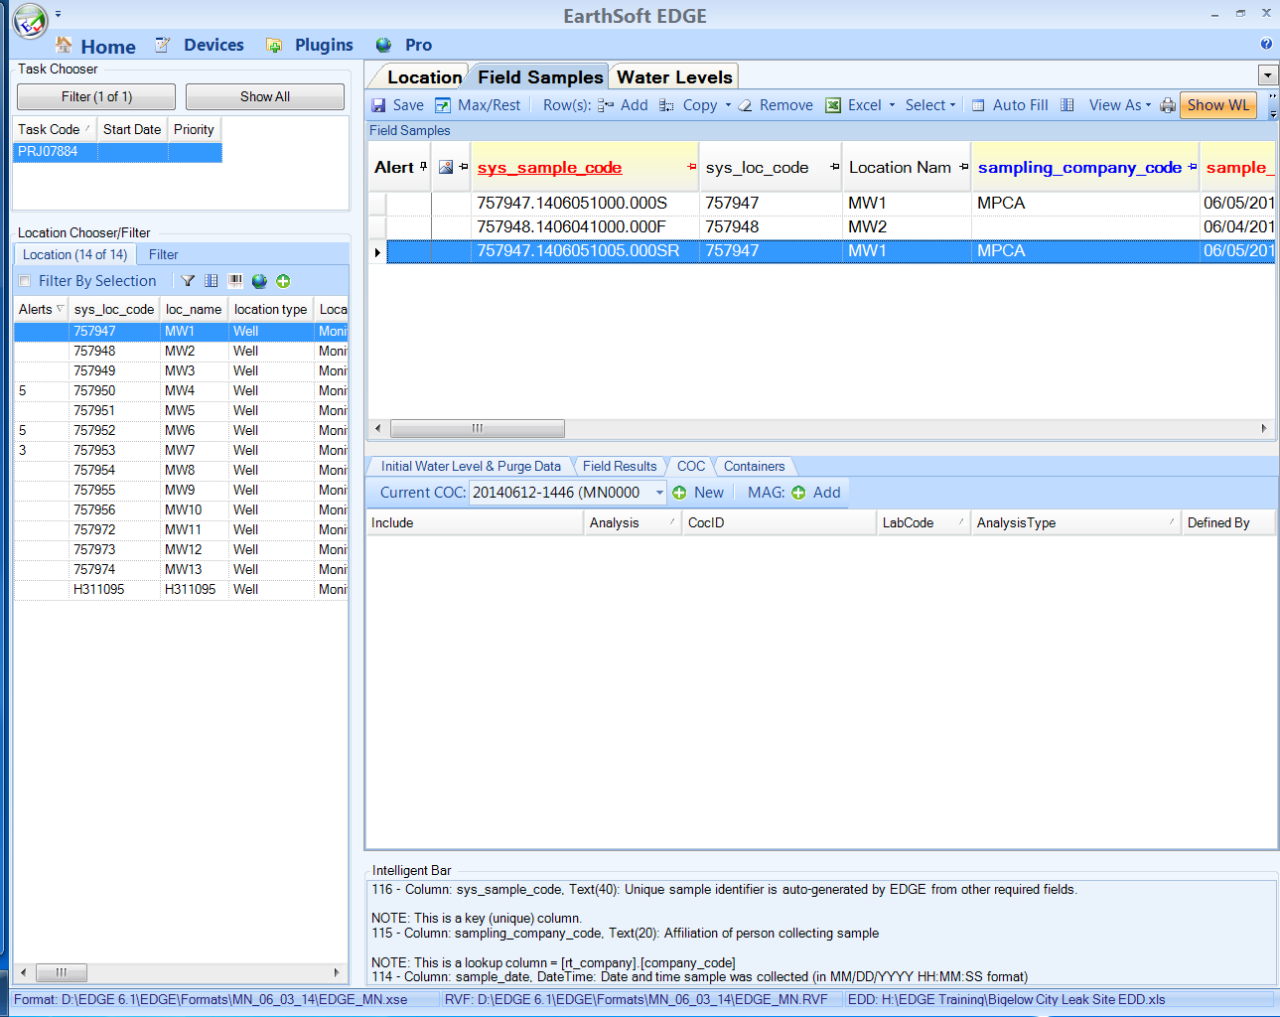

    - Click on the “EDP Export” button in the upper left-hand part of the computer screen.
    - A screen will appear titled “Prepare EDD for Sign and Submit”
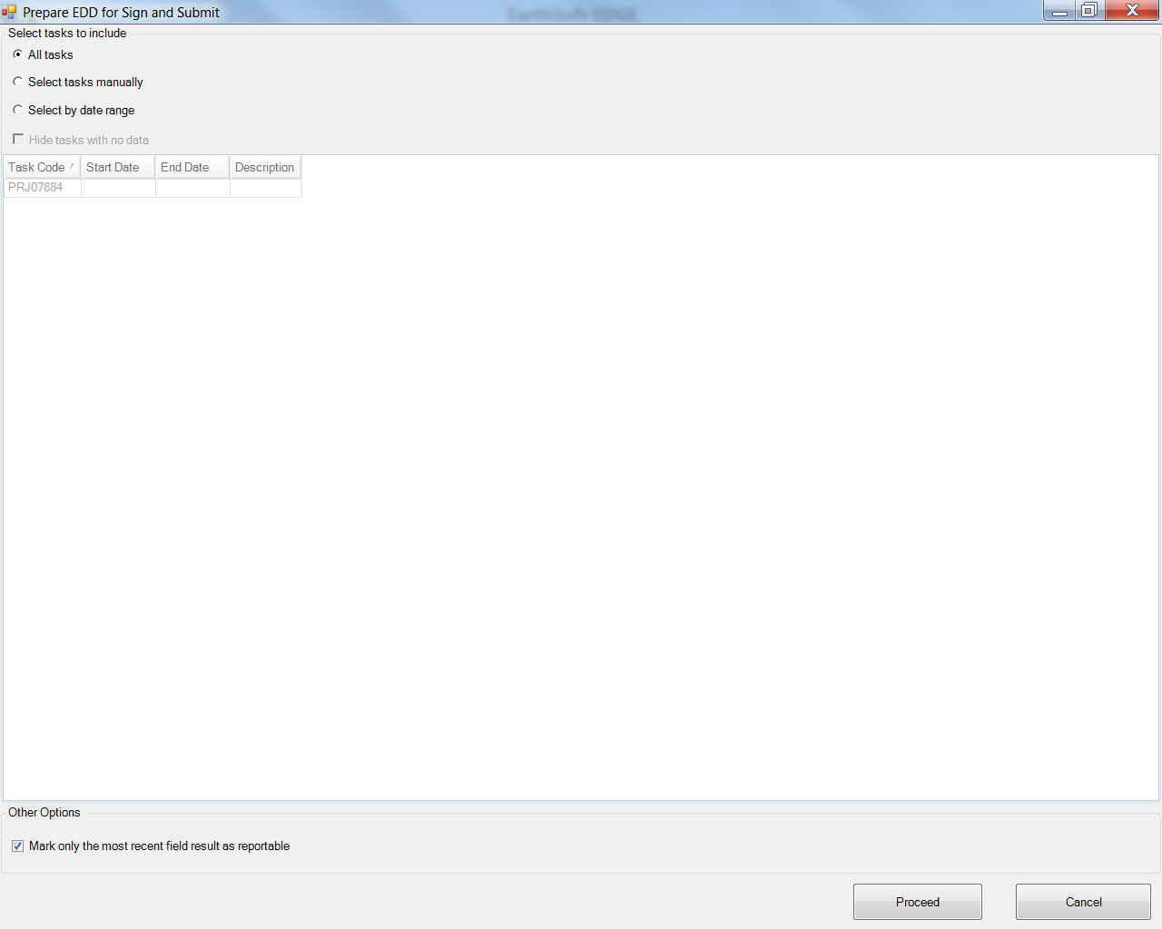

    - Keep “All tasks” selected if you want to include all tasks. Alternatively, select “Select Tasks Manually” to select specific tasks.
    - Make sure the box next to “Mark only the most recent field result as reportable” is checked.
    - Click on the “Proceed” button.
    - A screen will appear prompting you to enter a User Name and a Password.

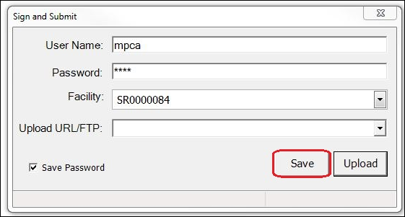

    - Enter “MPCA” as the user name AND the password.
    - Enter the site ID in the Facility field – in the above example: SR0000084
Note: Use the 9-digit facility ID (Program Site ID) for Superfund, Brownfields, Petroleum Remediation and Site Assessment sites. For CLP sites, use the SW number (SW-25, for example). For RCRA Remediation sites, use the MND number (MND064788243, for example).
    - Click on the “Save” button.
    - A screen will appear prompting you to save; select the file location and name the file.

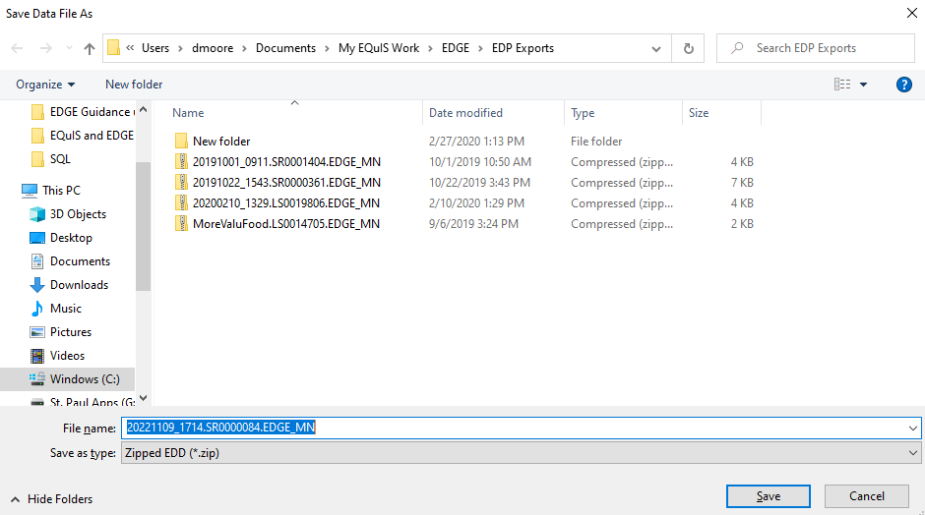

    - The default file name will include the date and time the file was created. You can edit the part of the file name to the left of the first period, “20221109_1714” in this example, to identify your project: July_2018_Baytown_Wells.SR0000084.EDGE_MN.zip, for example.
Note: You must keep the “.SR0000084.EDGE_MN.zip” part of the file name (the .zip will be added after saving).

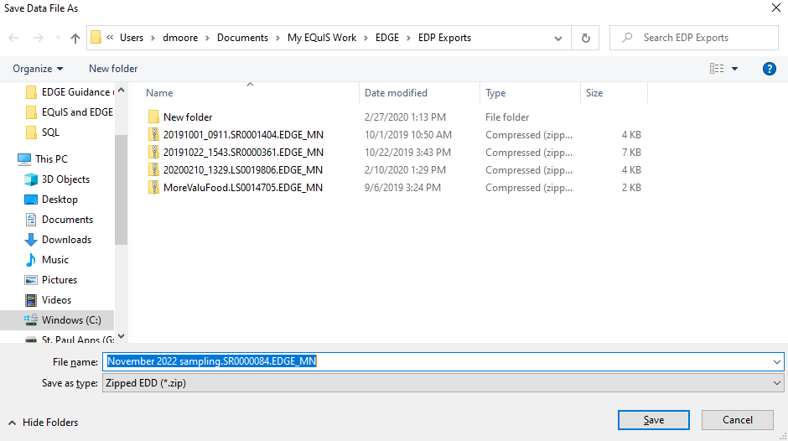

    - Click on the “Save” button to save the file.

    - A screen will appear confirming the EDD was saved.

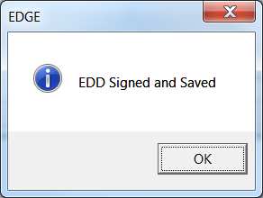

The saved EDD, in this example “November 2022 sampling.SR0000084.EDGE_MN.zip”, should be emailed to remequis.mpca@state.mn.us. (EDGE EDDs for CLP sites should be emailed to WQData.mpca@state.mn.us.)

Appendix A: Obtaining Location Unique Identifiers (sys_loc_codes)

EQuIS joins laboratory analytical data and EDGE field data using a system-unique identifier called the sys_loc_code. The sys_loc_code is EQuIS’s most important primary key and is required for each sample location. Because sys_loc_codes are location specific, we refer to them as Location Unique Identifiers, or LUIs.

You will need to obtain Location Unique Identifiers (LUIs) for new sample locations from the LUI Generator. A link to the LUI Generator is at the bottom of the LUI Generator Description webpage: https://www.pca.state.mn.us/location-unique-identifiers-luis. For sanitary sewer, sediment and surface water LUIs, email the Remediation EQuIS team at: remequis.mpca@state.mn.us. In the email request, identify the number and types of locations you will be sampling and provide UTM coordinates and sample location names for each location. If you are sampling in a lake, stream or sediment in a lake or stream, include the DNR lake ID with your request.

The MPCA will generate LUIs and send them to you, within one week of your request.

Note: The MPCA does not issue permanent well LUIs. Permanent wells use Minnesota Unique Well Numbers as LUIs, which are provided on the well permit issued by MDH.

The figure below shows the different types of LUIs.

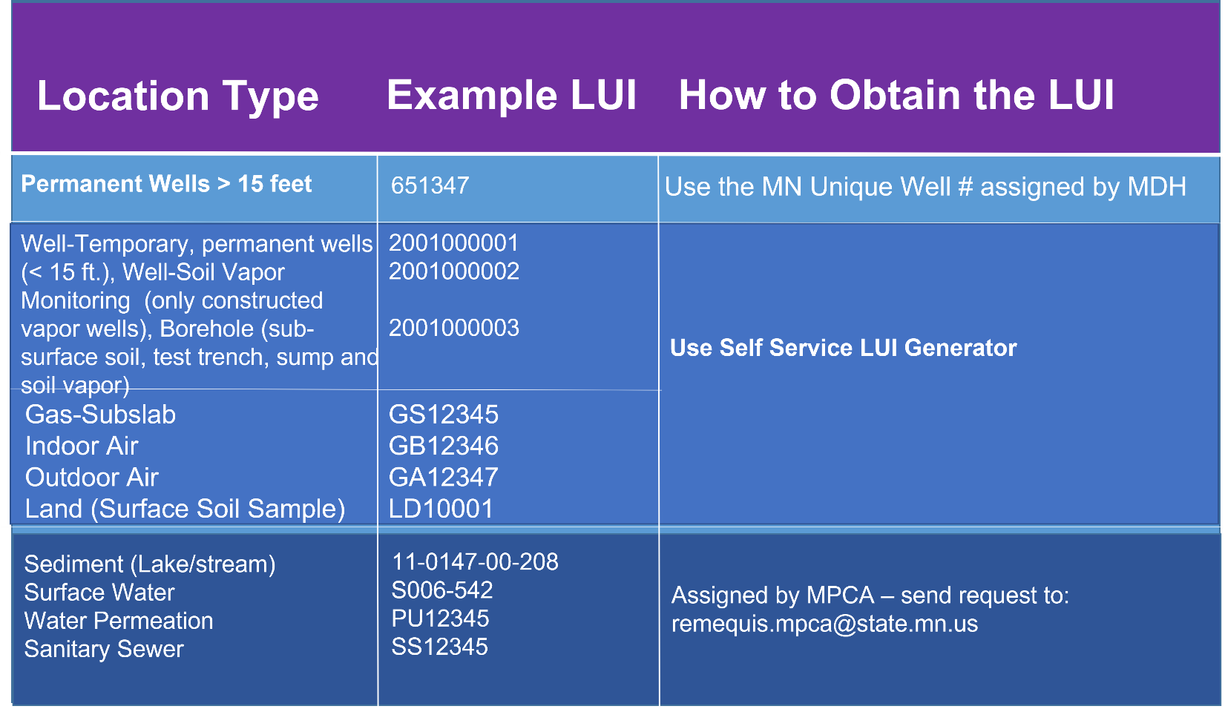

Note: Locations that have been sampled previously, such as a sub-slab port, indoor air and outdoor air likely have assigned LUIs already. Do not request new LUIs for locations that already have LUIs assigned. If you are uncertain, ask the Site PM or the Remediation EQuIS Coordinator.

Appendix B: Obtaining MN Unique Well Numbers for Older/Existing Wells

Minnesota Unique Number History
Most of the records in CWI are for wells drilled since 1974, when regulations were updated requiring drillers to submit records for wells drilled in state to MDH. Wells drilled prior to this date may or may not have unique numbers. Domestic/private wells drilled after 1974 almost always have CWI numbers.

Because monitoring wells were not used for drinking water, regulation of soil and exploratory boring companies lagged that of well drillers. Most monitoring wells drilled from 1972 through 1986 did not have an official well record submitted to the MDH. The driller’s records for monitoring wells are likely found at the MPCA (or, for pesticide and fertilizer spills, MDA). An on-going data acquisition project at the MPCA is attempting to collect these historical driller’s records and enter them in both CWI and in the MPCA’s EQuIS database.

Verification of MN Unique Numbers
The best way to check a MN Unique Number is to visit the well in question and see if it has a placard with the MN Unique Number on it. This isn’t always practical, but it could be an opportunity to survey the coordinates of the well head. The coordinates are needed for EQuIS and for obtaining a MN Unique Number where none exists.

Identify the Unique Number for the Well
It is very important to take the time to determine whether a unique number has already been assigned to the well because duplicate numbers causes everyone, especially MGS and MDH staff, to waste time eliminating them. It may require as much as several hours staff time to track down and eliminate the duplication and this a waste of public resources. Here are tips for determining whether a unique number has already been assigned:
- If you verified that the well record submitted to MDH matches the well that is being sampled, then the unique number is listed on the upper right-corner and lower left corner of the form. It should be a six-digit number that matches the series numbers for MDH that is listed in the previous section of this document.
- Look for the well on the Minnesota Well Index site at https://www.health.state.mn.us/communities/environment/water/mwi/index.html. This web application does not include public water supply wells.
Wells with verified locations will be shown in the map or air photo view. Wells without a verified location will be listed in a table that uses the geographic location that is supplied by the water well contractor. The unique numbers listed will include 1B and 2B-series numbers.
- Check with MGS staff to determine whether they have any historical well records for the site you are interested in that are not currently being served out on the Minnesota Well Index site. A backlog of unscanned well records without a verified location are on file at MGS, sorted by township, range, and section and available in paper form only.
- For monitoring wells, temporary monitoring wells, and soil borings, check with MPCA staff to determine if a unique well number has been assigned as part of a historical data harvesting event or updated sampling.
Assign a unique number to the data that has been collected about the well.
Use the unique number that has already been assigned to the well when it is known. If a unique number cannot be identified, then one can be assigned from the block of numbers that is assigned by MGS. Contact MGS staff for block number requests.
Be sure to confirm that you have written the correct number on any hard copies of data that you have collected for the well because it is very easy to incorrectly write a six-digit number. Be care to avoid mistakenly assigning the incorrect unique number to data that has been collected for another well.

Appendix C: How to update the .rvf file

The .rvf file contains drop-down reference values, which occasionally change. The most likely values to change are analytes; for example, Dioxane was added in 2017. The MPCA will send updated .rvf files to the EDGE user group, via the Gov Delivery list serve.

Copy the new .rvf file into the \EDGE_v61\EDGE\Formats\MN_06_03_14 subfolder.

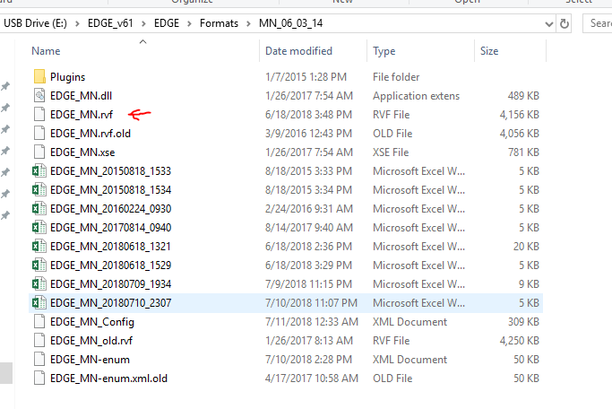

Appendix D: Where are Files Saved?

Click on the EDGE button in the top of the screen and then click the Options button. Scroll to the bottom of the EDGE Options window, and in Working Folders you can see and change output destinations for various files.

